Automatic Measurement System for Cargo Volume

Sponsor: Panasonic

Mentor: Zhuosi Zhang

Instructor: Mingjian Li

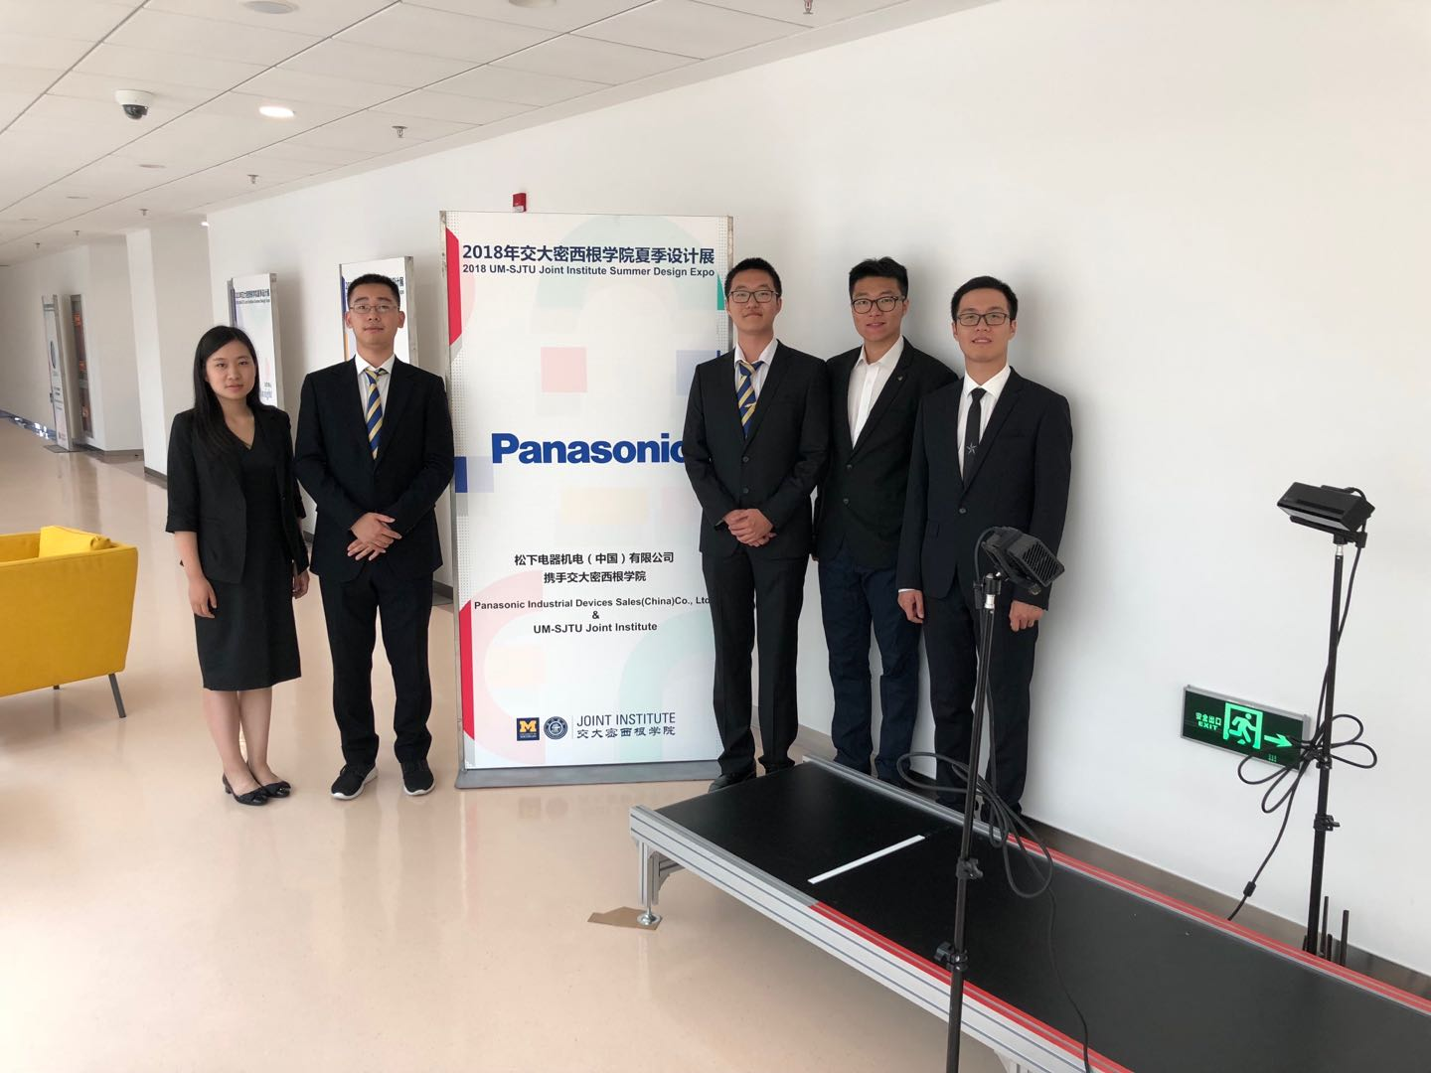

Group members:

Xinyi Wu, wu.xinyi@sjtu.edu.cn

Zesen Wang, UncleSam@sjtu.edu.cn

Yetong Zhang, gibbonzyt@sjtu.edu.edu

Yier Zhang, yier_0227@sjtu.edu.cn

Zitao Zhang, crazybullet28@sjtu.edu.cn

**Executive Summary**

With the rapidly growing needs of cargo delivery in China, it is necessary to develop an automatic system that can efficiently measure the volume of goods during the packing and loading process of cargo transportation. To restore the environment in delivery company, our system is supposed to return the volume and shape of the cargos on a conveyor belt automatically. In order to be competitive with existing products of cargo volume estimation, the system needs to be accurate, time efficient, and cost saving. These are the requirements from our customer, and therefore the objectives of our project.

After analysis on the customer requirements, we think depth cameras are suitable for our project. They can accurately return the distance of points in the range of several meters, and the cost is lower than the existing systems using laser measurers. We will also use camera supports and light reflection tape in aid with the depth cameras. The engineering specifications should include speed of conveyor belt, number of depth cameras, filming angle difference, camera distance, cargo size range, max unilateral error, processing time, and cost restriction. Among all these engineering specifications, the most important one is the “cargo size range”.

In our system, we apply two depth camera to construct the point cloud of the cargo. Reflective tapes are placed on the conveyor belt for calibration purposes, and help with the alignment of point clouds reconstructed from different views. The aligned point clouds are then being denoised and post-processed. Finally, a convex-shape is generated from the point cloud, and the volume of the cargos are estimated from the reconstructed shape.

Our algorithm runs on a single computer with Ubuntu environment. Our system estimates the shape and size of cargos with sizes ranging from 10*10*10 $cm^{3}$ to 40*40*40 $cm^{3}$, and achieves the accuracy of unilateral error within 8%. The processing time for each cargo is within 1*s*, enabling the system to perform real-time size estimation in real-world application.

There are still some flaws of our system. The detection accuracy still needs to be improved compared to existing products. There is also a limit on the spatial distances between consecutive cargos.

Overall, our system lives up to our customer requirements and specifications. It is a cheap and practical solution to the real-world cargo volume estimation problem.

**Table of Contents**

**Introduction** **3**

Background 3

**Specifications** **5**

Customer Requirements 5

Engineering Specifications 5

QFD Chart 6

**Concept Generation** **8**

**Concept Selection** **10**

**Concept Description** **12**

**Parameter Analysis** **19**

**Final Design** **20**

**Manufacturing Plan** **21**

**Test Results** **23**

**Engineering Changes Notice (ECN)** **25**

**Analysis of Potential Problems** **26**

**Discussion** **27**

**Recommendations** **28**

**Conclusions** **29**

**Acknowledgements** **29**

**Information Sources and Reference List** **30**

**Appendices** **32**

Appendix A. Bill of Materials 32

Appendix B. Illustration of solutions and concept selection process 32

Appendix C. Project Timeline and Schedule 33

**Bios** **34**

# 

# Introduction

Our project aims at improving the efficiency of the packing and loading process during cargo delivery. The motivation of our project is the quickly growing demand of cargo delivery in China. The packing and loading process is an important part of cargo delivery. Due to limited capacity of transportation tools, how to take good use of the full capacity of transportation tools directly impacts the delivery speed. And this calls for the accurate measurement of the volume of the goods. The primitive way to measure the volume of goods is manual measurement, which is slow in speed, error-prone, and have problems in special-shaped measurement. A better way is to use laser technology, but the cost is too high.

Our objective is to develop a low-cost system that can automatically measure the volume and shape of goods on a conveyor belt. The hardware we will use are two Kinect depth cameras. The cameras will be placed in two different positions and take pictures of the goods on the conveyor belt. We will use algorithms to integrate information from both cameras and reconstruct the shape of the goods in computer. The volume of the goods will be calculated, and a three-dimensional model map will be built.

## Background

Our project is based on several cutting edge technologies: KinectFusion algorithm, the optical system for detecting three-dimensional shape, video-based shape detection apparatus, and autofocusing and image detection at each focus level. Following are detailed illustrations of these technologies.

KinectFusion Algorithm [1]:

The main idea of KinectFusion Algorithm, as shown in Figure 1, is to allow user to reconstruct a 3D scene in real-time by moving the Kinect camera around the real scene. At every frame, it uses the built-in function to generate a point cloud according to the depth figure. Then, to align and combine the current point cloud and the previous one, it uses Iterative Closest Point (ICP) [3] to find the best transformation. At the last step, it uses the greedy triangle algorithm to reconstruct the surfaces according to the point cloud.

The drawback of the algorithm is that it requires large computation capacity (GPU, Nvidia GTX480 in an open source implementation [4]) to obtain the real-time construction. Also, the algorithm does not fit our problem because it does not filter out the background and, in our problem, the object is moving while the Kinect sensors are fixed.

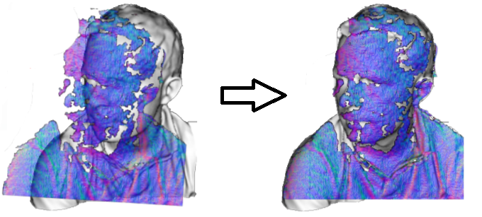

Figure 1. Demonstration of KinectFusion Algorithm [1].

Optical system for detecting three-dimensional shape[5]:

The system is designed to move a parallel beam of light in the direction normal to the object, reflect the beam by a mirror at a predetermined inclination angle, and produce an image of the object by the image forming lens, which converges the reflection beam to a point.

Though the system could produce a 3D shape of cargoes, it requires the measured cargo to be still. Therefore, the setting of a moving conveyor belt makes the system undesirable in our case.

Video-based shape detection apparatus[6]:

This is an apparatus patented by Panasonic, the sponsor of our project. The apparatus records the process of a object passing through by video, which could be considered as a consecutive sets of images collected at a relatively high frequency. The edges are identified according to changes in neighbouring images, calculated by the derivative. Further, the shape is then reconstructed by edges.

The apparatus manages to deal with moving cargoes. However, the high memory cost of and high computational requirements for taking videos for each cargo remain to be improved.

Autofocusing and image detection at each focus level[7]:

The key idea is to use the distances from points on the object to the camera. In order to get the distances, the system picks up a plurality of images of objects at different focus levels having different Z-axis coordinate values correspondingly, and then detects maximum focus measure values in pixels.

This system also requires the stillness of the cargo. Moreover, it is inefficient in taking a plurality of images and analyzing each of them.

# 

# Specifications

## Customer Requirements

Our customer requires our project design to have a high measurement efficiency, manpower saving, low cost and standardized measurement process. For the measurement setting, it should be easy to build and install, easy to use, able to handle different sizes and special shape cargos. For the measurement results, it should be accurate enough and can be visualized to the user. In summary, we have listed our customer requirements below:

1. High efficiency
2. Save manpower
3. Low cost
4. Standardize the measurement process
5. Easy to build and install
6. Easy to use
7. High accuracy
8. Different cargo size capacity
9. Special-shape cargo measurement
10. Visualization output

## Engineering Specifications

From these given requirements, we generate engineering specifications by the following process:

First we define the background setting, which includes the speed of conveyor belt, the cargo size range, and the estimation of processing time. These properties are related with the efficiency of measurement. Thus, we simulate a circumstance of the usage of our project, such as long assembly line operations and packing. Under this kind of situation, the cargo size should be within the range of 5*5*5 $cm^{3}$ to 50*50*100 $cm^{3}$. After experiments, rather small or big cargos are very difficult to measure. Therefore, we modified the range to 10*10*10 $cm^{3}$ to 40*40*40 $cm^{3}$. This specification is highly related to the “standardize the measurement process” and “different cargo size capability”, so we give both categories 9 points in the QFD table (Figure 2).

For the speed of conveyor belt, we initially restricted the speed within 0.2-0.5 *m/s*, because it is the most common speed of conveyor belts of our size. After several groups of experiments, we find out that when the speed is at 0.4*m/s*, the unilateral error was the smallest. So we decide to use 0.4*m/s* as the speed of our conveyor belt. Since the speed of the conveyor belt decides the efficiency of our system, we give it a 9 in “high efficiency”.

For the number of cameras, since we need to handle with special size cargos, 2 depth cameras are necessary to film at different angles to get a more detailed cargo shape. Considering the cost limitation and the accuracy requirement, we don’t need to have more depth camera. For the position and filming angle, we decide to place the camera at both sides of the conveyor belt. Since the camera has 43° vertical by 57° horizontal field of view[9], we need to put them at a distance about the same as the maximum length of the object to catch the whole object. To capture the front or rear side, we need even longer distance. So the distance we put our camera is 1 meter. In addition, to make a clear reference points on the conveyor belt, the filming angle range shouldn’t be set too large. -60° . to 60° . should be a good choice. These specifications are highly related to “different cargo size capability” and “special-shape cargo measurement”, so we give them relatively high points. And they are also related to “standardize measuring process”, “easy to build and install” and some other factors, we gave them lower points in the QFD table.

As for the maximum unilateral error, we searched for some articles. It is found that errors increase quadratically from a few millimeters at 0.5*m* distance to about 4*cm* at the maximum

range of the sensor which is about 6 meters. [10] We also checked the report of two other groups of people that used depth camera to measure volume, and their percentage errors for volume are between 0.1% to 16%. [11][12] Consider the object they measure are smaller than ours, and their distance of camera is smaller than ours, we estimate our unilateral error to be no larger than 10%. We consider accuracy as an important part of high efficiency, so we give it a 9 in “high efficiency” in the QFD table.

Our cost consists of three parts: Kinect cameras, camera support, light reflective tape. The cost for conveyor belts and computing tools (computers) will not be considered since they are off the shelf. The cost for two Kinect cameras is 1488*2 = 2976RMB. The camera supports are about 30*2 = 60RMB. The cost of light reflection tape is about 10RMB per meter of the conveyor belt. In total, the cost is about 3500RMB (suppose the target conveyor belt is 20*m* in length). This one is most related to low cost, so we give it a 9 in “low cost” in the QFD table.

In summary, the engineering specifications are:

1. Speed of conveyor belt (0.4*m/s*)
2. Cargo size range (10*10*10 $cm^{3}$ ~ 40*40*40 $cm^{3}$)
3. Processing time (1*s*)
4. Number of depth cameras (2)
5. Filming angle range (-60° ~ 60°)
6. Camera distance (1*m*)
7. Max unilateral error (10%)
8. Cost restriction (3500RMB)

## QFD Chart

Our QFD is shown in Figure 2. Among all the customer requirements, the most important one is “different cargo size capacity”, then follows “easy to use”, and then “high efficiency”, “save manpower”, and “standardize the measurement process”. Because the usage of our project is likely to be in long assembly line operations and packing, so it’s very important to ensure that our design can measure the cargo volume with various size.

Among all the engineering specifications, the most important one is the “cargo size range”, then follows the “camera distance” and the “max processing time”. The first 2 are both correlated to the CR of “different cargo size capacity”, so they both have high weights. And the “max processing time” is correlated with “high efficiency”, “save manpower”, and “easy to use”.

We need to always focus our attention on these high-weight specification during our project design to make sure that the customer requirements can be fulfilled.

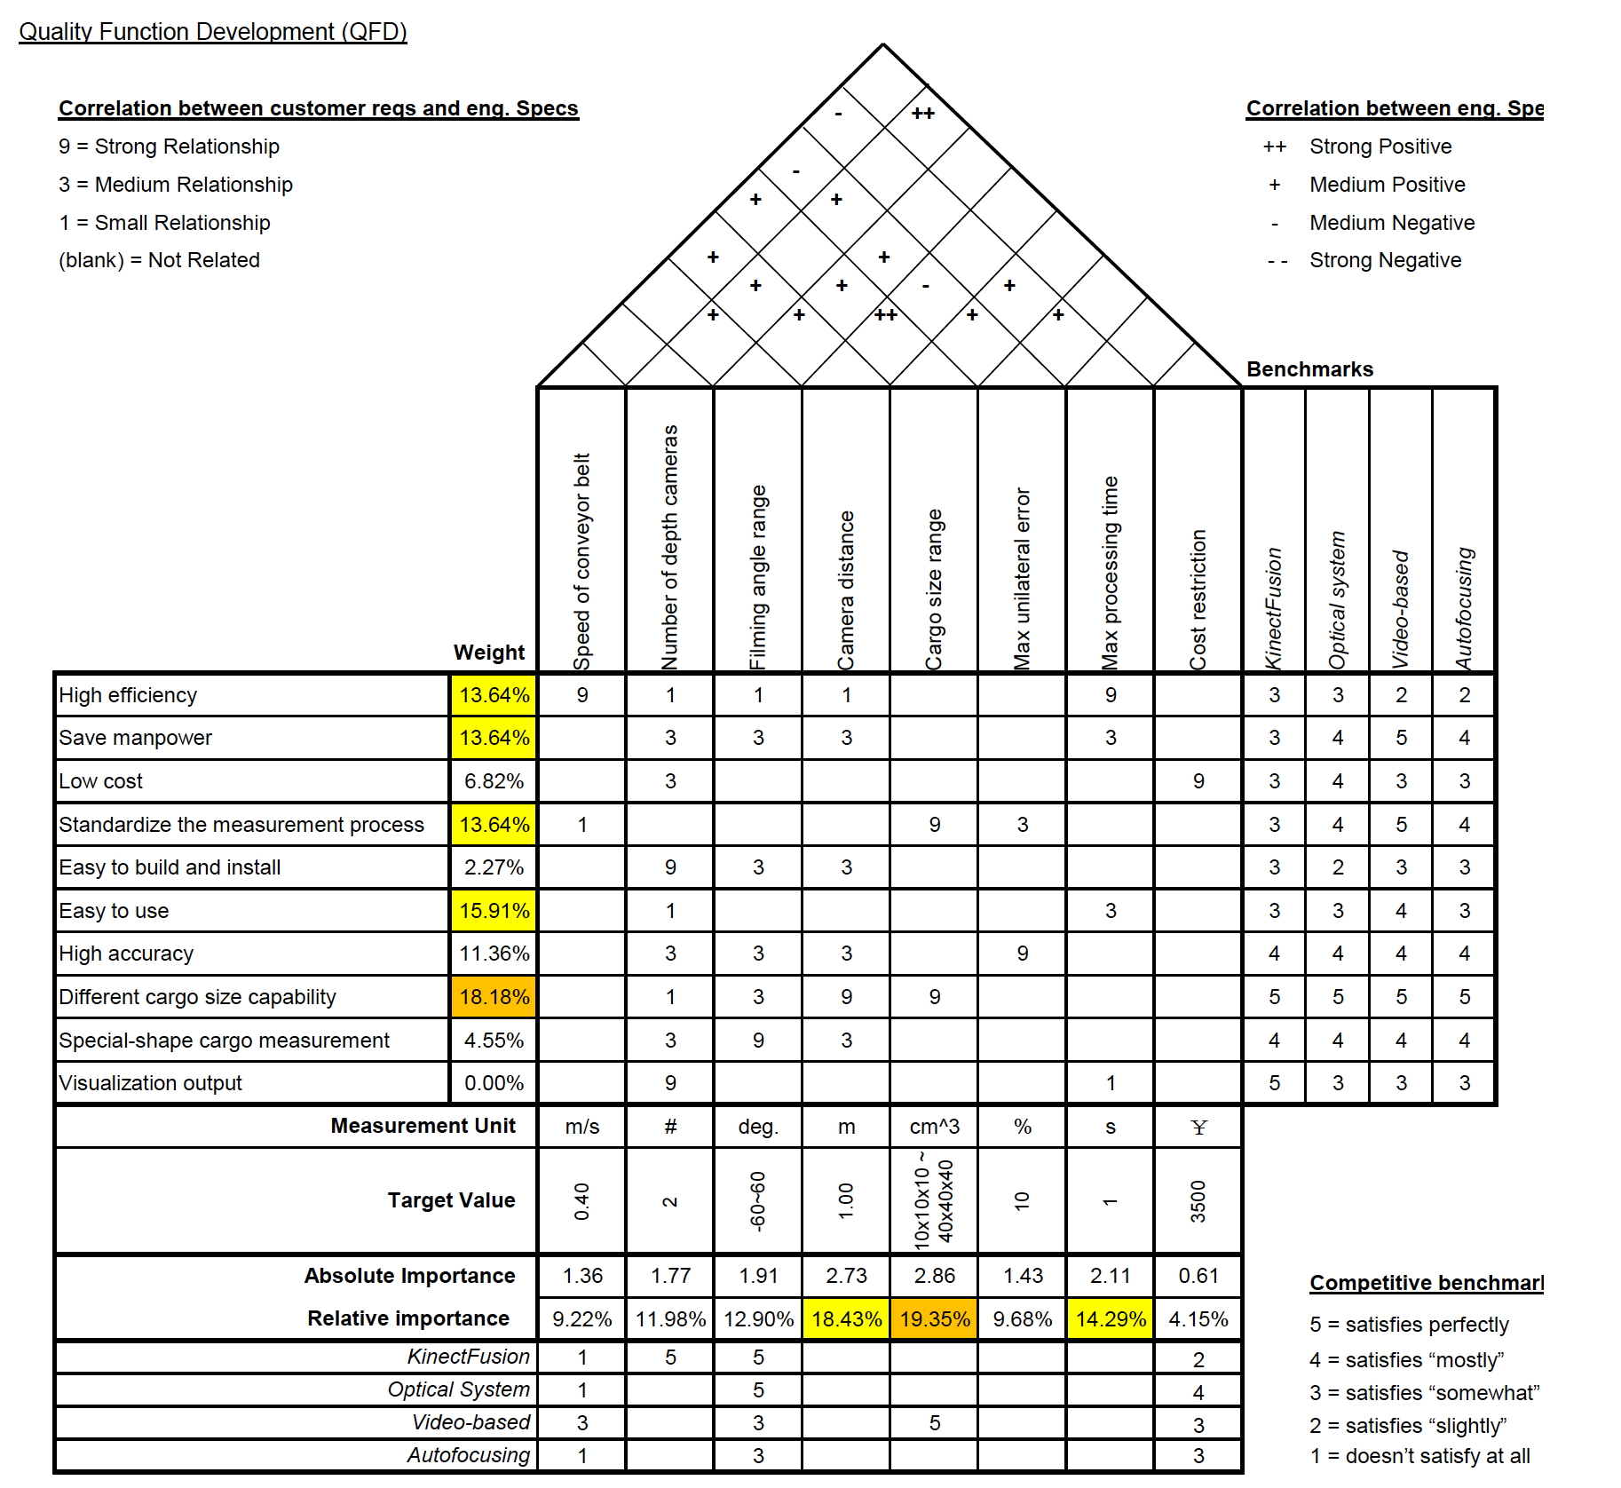

Figure 2. Quality Function Deployment (QFD) Chart.

# Concept Generation

In the concept generation process, we first brainstorm for possible solutions to the problem. Then, we decompose our concept into different functional components, and document the solutions into a morphological chart for the selection process.

## 

During our brainstorming process, we have the four main categories of our solution:

the first category uses calibration marks on the conveyor belt to assist point cloud alignment, as shown in Figure 3. By aligning the point cloud taken by different cameras of the cargo, we can construct the shape of the cargo, and estimate its shape and volume. The marker can be constructed using the reflection tape, because it can reflect most of the infrared lights, and appears as a bright strip in the infrared image.

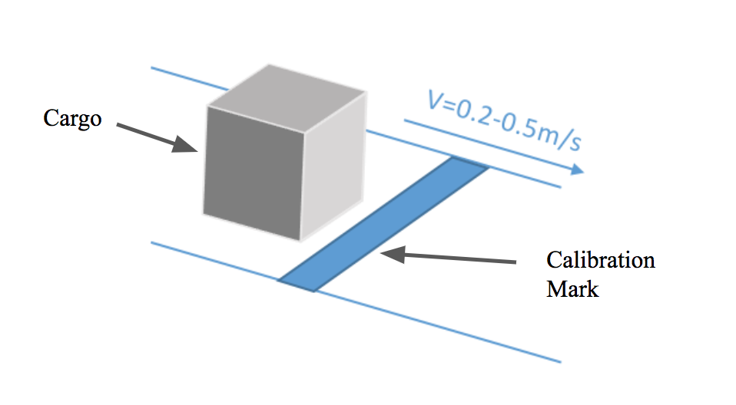

Figure 3. The calibration mark on the conveyor belt

The second category uses deep learning approach to calculate the point-to-point correspondence, by estimating optical flow between two images taken at different views. Using the correspondence relations, we can reconstruct the point cloud of the cargo. The state-of-the-art research on optical flow estimation has enabled the optical flow estimation with high precision[13] as shown in Figure 4, and there exists large datasets to assist the training process.

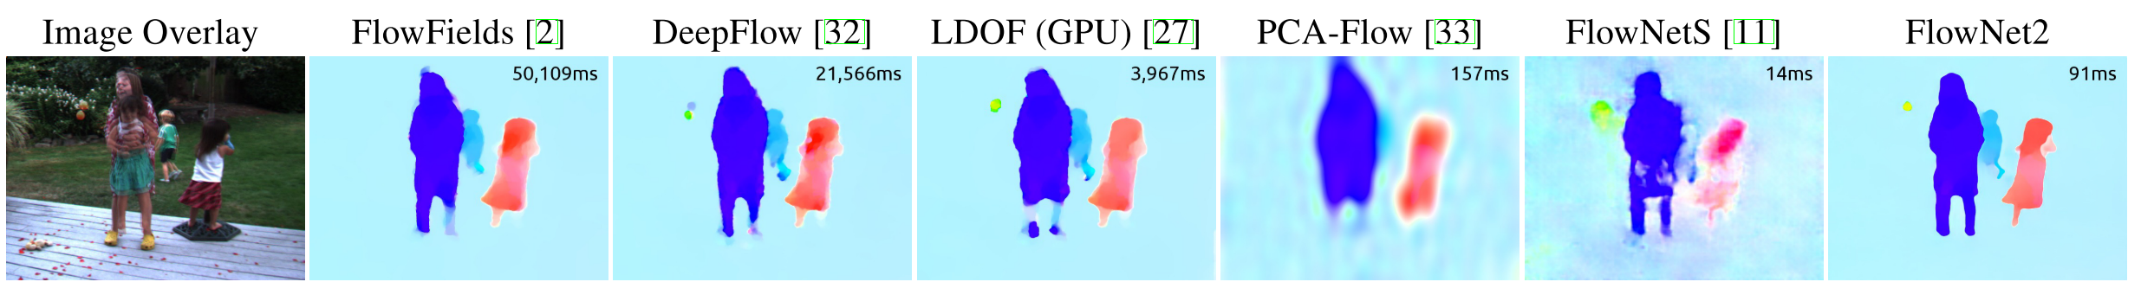

Figure 4. The state-of-the-art flow estimation results[13]

The third category aligns the point cloud of different images by aligning the corners of cubic object, as shown in Figure 5. First, the algorithm detects the corners of the object for each frame. Then, by aligning the corner of the object, the algorithm can calculate the transform between point clouds constructed from different images, and form the final point cloud of the cargo.

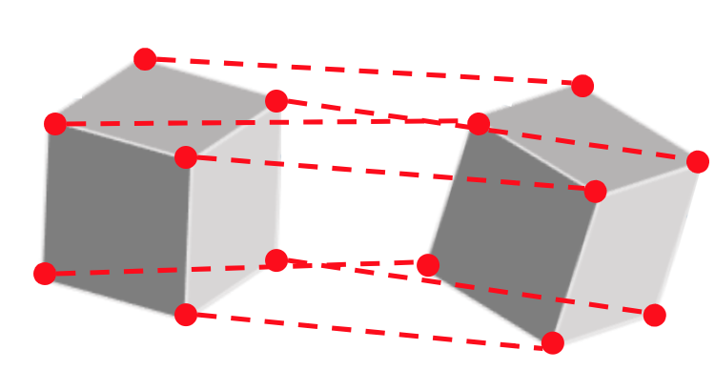

Figure 5. Point Cloud alignment by aligning the corners of object

The fourth method uses classical point cloud alignment methods to align the point clouds of different frames to reconstruct the shape of the cargo. There are various methods to align point clouds including Random Sample Consensus (RANSAC) method [14], Iterative Closest Point (ICP) method [15], and Principal Component Alignment (PCA) method [16].

The solution to the following functional components are documented in the morphological chart as shown in Table 1. Detailed explanations of each concept and solution are provided in Appendix B.

1. The placement and fixture for the Kinect cameras
2. The placement of markers
3. Point cloud alignment algorithm

|  |  |  |
| --- | --- | --- |
| **Kinect Camera Placement** | **Marker Placement** | **Point Cloud Alignment** |
| 90° | no marker | marker |
| 45° | marker on sides | optical flow |
| 45° (staggered) | marker in the front | corner alignment |
| 0° |  | RANSAC |
|  |  | ICP |
|  |  | PCA |

Table 1. Morphological chart for cargo volume estimation.

# 

# Concept Selection

We apply Pugh Chart to select our concept for each functional component, as shown in Figure 6~8. Since point cloud alignment is the main functional component of the project, its selection process is discussed in detail in this section.

**Point Cloud Alignment:** The point cloud alignment algorithm is directly related to the accuracy of shape reconstruction and the execution time, which are two important engineering specifications for the project. Thus, we have decided the following score matrices based on the engineering specifications: flexibility of shapes, tolerance to outliers, and computational cost. The “flexibility of shapes” reflects the performance of the algorithm on cargos of different sizes and shapes. Since most of the cargos are of the cubic size, as told by our sponsor, we assign weight 1 to the factor. Since most of algorithms work well in the outlier-free case, the factor “tolerance to outliers” reflects the accuracy of the alignment in case of outliers. Since the performance on size detection accuracy is important, we assign weight 2 for the factor. The computational cost reflects the computing time for the algorithm, and we also assign weight 2 to the factor because of the limitation on the computing time.

The RANSAC algorithm randomly select points from the point cloud, and then fit a shape based on the selected point. Then, the algorithm counts the number of points in the point cloud that agree with the fitted shape. The process is repeated several times, and the shape with most number of agreements is chosen as the target shape. Since the algorithm requires repetitively fitting shapes and calculating agreement, it has high computational cost, while it is robust to outliers. The algorithm also has a low flexibility of shapes, since we can only fit one shape at a time to the selected points.

The PCA algorithm computes the principal components of the point cloud, and calculate the transform between the two point clouds by aligning the principal components. The algorithm has lower cost than RANSAC, since it does not require repetitive computation. However, the process to compute the principal components requires the information of all the points, therefore the algorithm is not robust to outliers, and the principal component computation requires much computation power.

The ICP algorithm iteratively match each point in the first point cloud with its closest point in the second point cloud. Using the correspondence relation of all the point pairs, singular value decomposition (SVD) method is used to calculate the transform between the two point clouds that minimizes the least square error of point-to-point distances. The computational cost is high since it requires iterative computation, while a good result can still be generated with a few times of iterations. The algorithm is more robust to outliers than PCA, while less robust than RANSAC.

The algorithm that uses markers has the lowest computational cost and is robust to outliers, since it does not require the point cloud to compute the transform. The only error of the method is the inaccuracy of the detection of the markers.

The algorithm that uses optical flow has the highest computational cost, and is commonly implemented with a GPU. Due to the limitation of computing power, the algorithm can hardly be implemented.

The corner alignment method has rather low computation cost, since it first extracts the feature of the corners, then uses the alignment of the corners to align the point clouds. However, in the case of outliers, the algorithm may falsely detect the outliers as the corners, which may cause severe problems. In addition, the algorithm may not work well for shapes with smooth surfaces.

**Camera Placement:** For the placement of cameras, we need both cameras to look at the cargos from different views so that we can see the entire object. In addition, the cameras cannot take images of the cargo at the same time, since there is interference of the infrared lights. The 45° staggered configuration can view the cargo object from all the directions, and the staggered placement reduces the interference between the two cameras.

**Marker Placement:** For the placement of markers need to be efficient for detection and alignment computation, and easy to assemble. Both the side placement and front placement are efficient for computation, but the front placement is easier for the assembly process.

Based on our analysis, we select the 45° staggered configuration for the camera placement; difference method for background elimination, and use calibration marker to assist the point cloud alignment, and then use ICP to refine the alignment. For the marker placement, we choose to place the marker in front of the object.

|  |  |  |  |  |  |
| --- | --- | --- | --- | --- | --- |
| Design Criteria | Weight | 90° (baseline) | 45° | 45° + staggered | 0° |
| Functionality of Cameras | 2 | 0 | 0 | ++ | 0 |
| Flexibility of Shapes | 1 | 0 | ++ | ++ | - |
| Computational Cost | 1 | 0 | - | -- | + |
| **Score** |  | **0** | **1** | **4** | **0** |

Figure 6. Pugh chart for Kinect camera placement

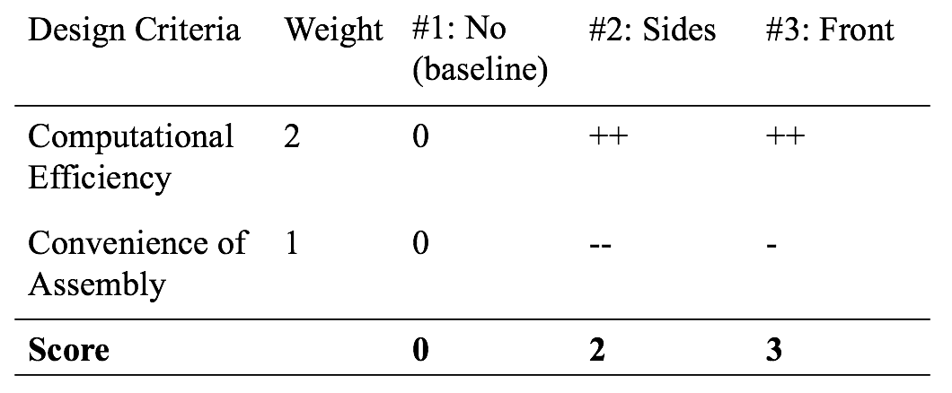

Figure 7. Pugh chart for marker placement

|  |  |  |  |  |  |  |  |
| --- | --- | --- | --- | --- | --- | --- | --- |
| Design Criteria | Weight | RANSAC (baseline) | PCA | ICP | Marker | Optical Flow | Corner Alignment |
| Flexibility of Shapes | 1 | 0 | ++ | ++ | ++ | ++ | - |
| Tolerance to Outliers | 2 | 0 | -- | - | + | - | + |
| Computational Cost | 2 | 0 | + | + | + | -- | + |
| **Score** |  | **0** | **0** | **2** | **6** | **-4** | **3** |

Figure 8. Pugh chart for point cloud alignment algorithms

# Concept Description

Figure 9 shows the setup of our system. The functional flowchart in Figure 10 demonstrates the functional components of our selected concept, and the interaction between the subsystems. The two Kinect cameras are placed in the 45° staggered configuration. There are reflection tapes mounted on the conveyor belt that function as markers. The depth images taken by Kinect cameras are used to construct the point cloud of the cargo, and the point cloud of different frames are aligned to reconstruct the 3D model of the cargo.

As shown in the functional flowchart in Figure 10, the system consist of mechanical part and software part. The mechanical part consists of the mounting of the Kinect cameras and the placement of reflection strips; the software part consists of algorithms for point cloud generation, background elimination and denoising, cargo detection, coordinate conversion and point cloud alignment, volume estimation, 3D model output.

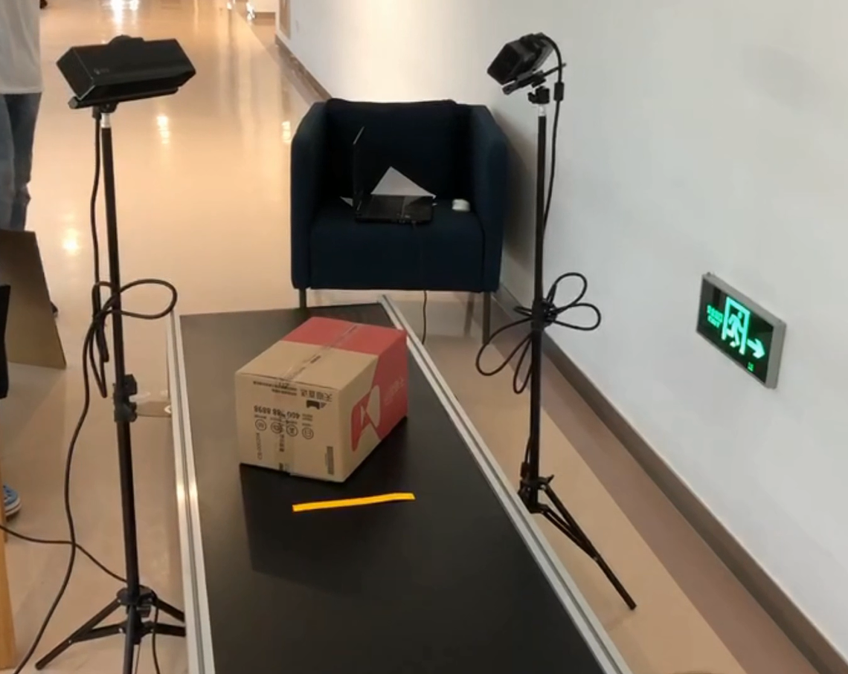

Figure 9. Setup for the cargo volume estimation system

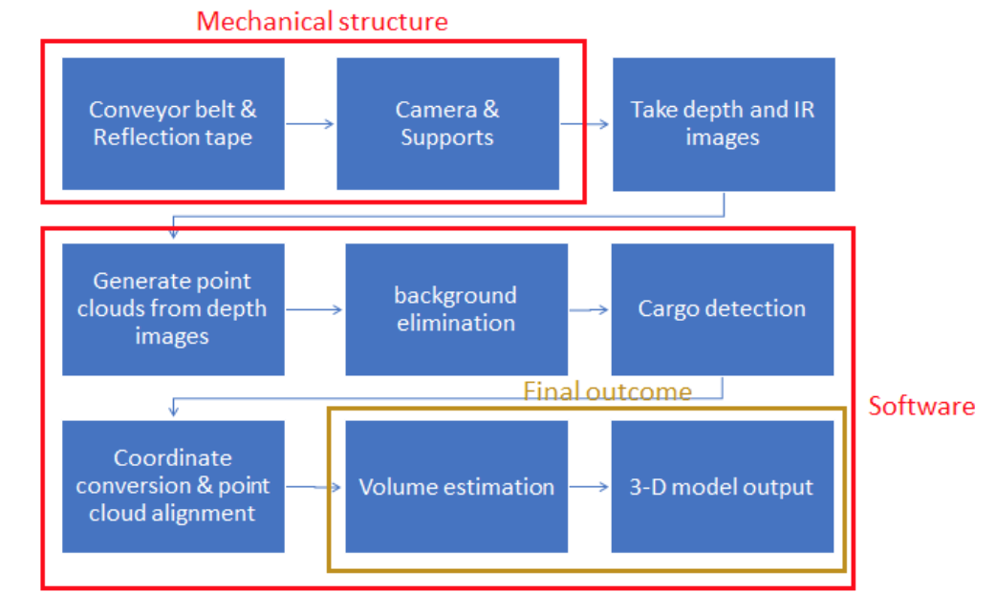

Figure 10. The functional flowchart for the cargo volume estimation system

**Mechanical Structure**: The schematic of the layout of our system is shown in Figure 11. The two cameras are placed on the two sides of the conveyor belt, and each camera is 1 meter from the central line of the conveyor belt. The distance between the cameras along the conveyor belt direction is 1*m*, and both cameras are placed at the height of 1.2*m* above the conveyor belt. The view angles of the two cameras are set as 45° staggered configuration, and each camera has a 45° view angle facing downward. The reflection strips are 3*cm* in width and 50*cm* in length, and mounted in parallel on the conveyor belt with a gap of 2 meters. The bill of materials for our system is provided in Appendix A.

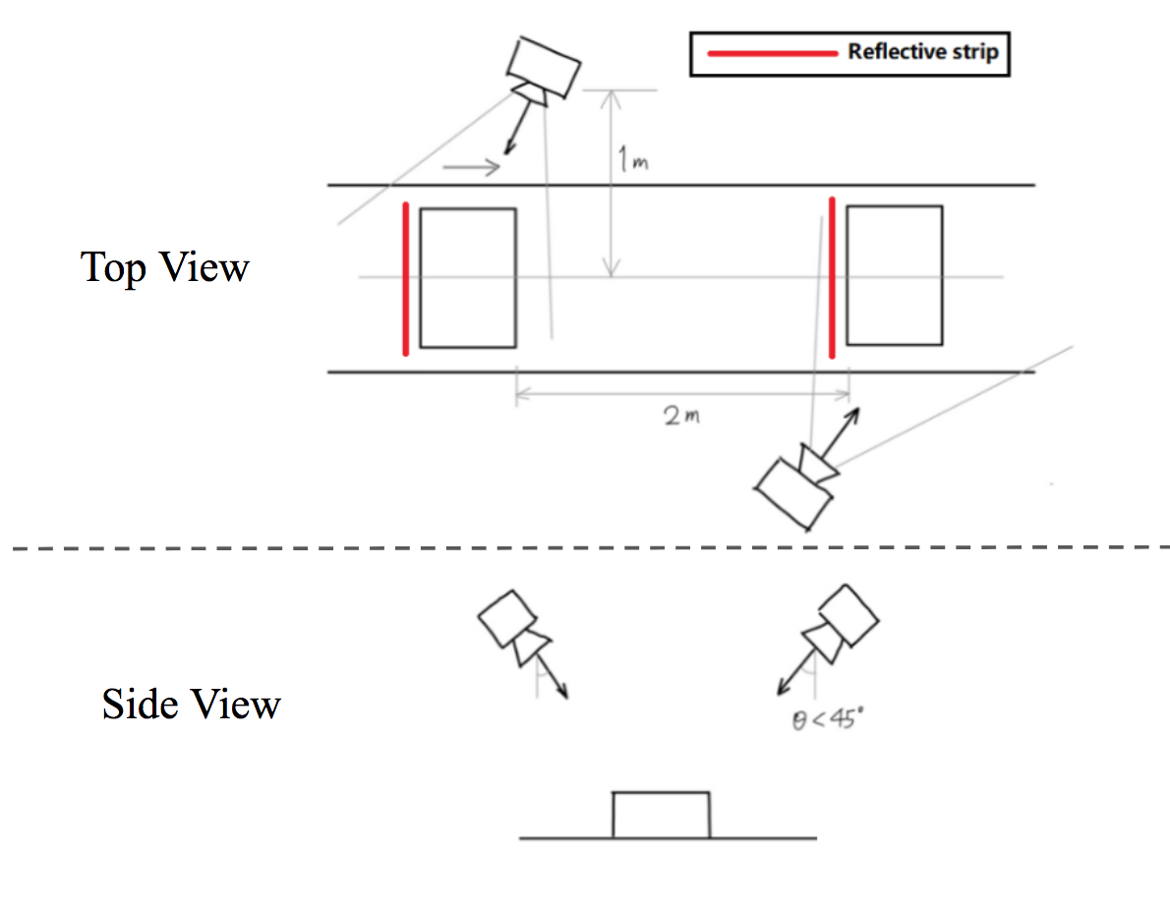

Figure 11. Schematic of system setup

**Point Cloud Generation**: Both Kinect cameras take depth images and infrared images, and the point cloud can be generated from the depth images. As shown in Equation 1, By applying the inverse of the camera intrinsic matrix $K$ to the homogeneous coordinate of each pixel point $(x,y,1)$, and multiplying with the depth value at the pixel point $d_{x,y}$, we can calculate the its real world 3D coordinate $(x_{world}, y_{world}, z_{world})$. Figure 12 shows the depth image and its corresponding point cloud generated.

$(x_{world}, y_{world}, z_{world})=d_{x,y}∙K^{-1}∙(x,y,1)$ (1)

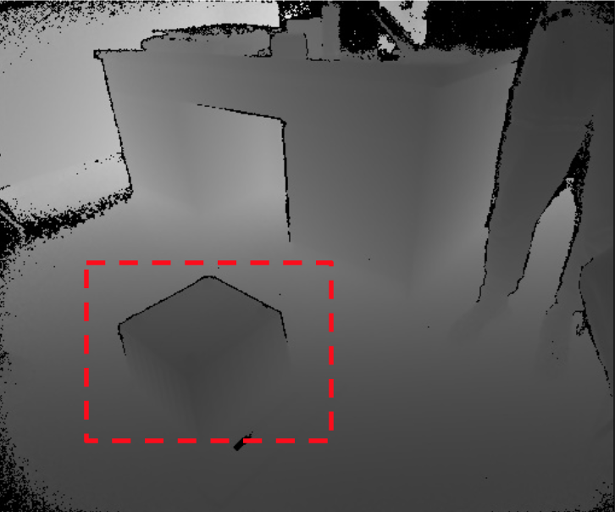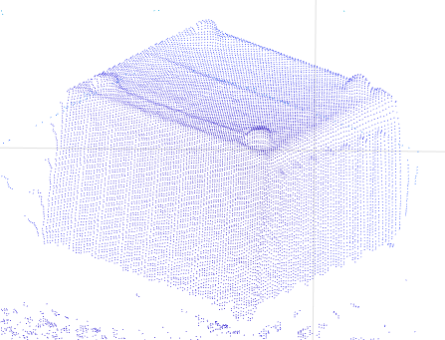

Figure 12. The image on the left shows the depth image by the Kinect camera; the image on the right shows the constructed point cloud of the object marked in the red bounding box

**Background Elimination**: Since the Kinect cameras are static relative to the background, the background in the images remain static. Thus, we can eliminate the background by first taking a picture of the background, then subtract the static background to calculate the moving parts, which represent the cargos and the reflective strips, as shown in Figure 13.

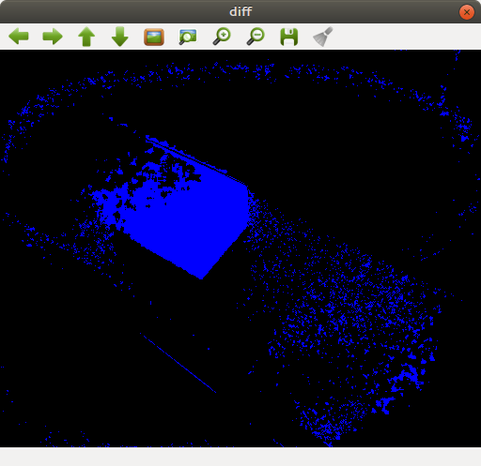

Figure 13. Subtracting the static background image, the cargo object and reflective belts become distinguishable.

**Denoising**: Since there are some noise in the generated point cloud, denoising is required to filter out the noise, and make the point cloud of the object clear. The source of the noise may come from the unflat surface of the conveyor belt, and random errors in the depth image. By applying the *morphologyEx* function in OpenCV, we can eliminate the non continuous points, and remain the integrable points which represent the cargo object.Figure 14 shows the point cloud before and after the denoising operation

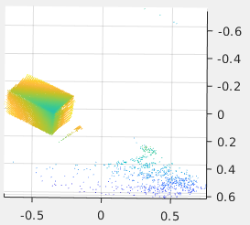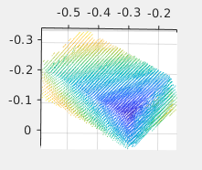

Figure 14. The point cloud before (left) and after (right) denosing

**Point Cloud Alignment**: Since the point cloud is static relative to the surface of the conveyor belt, we can calculate the coordinate transform of the point cloud from one frame to another by calculating the coordinate transform of the reflective belt. In the frames taken by the same Kinect camera, since the conveyor belt only has translational motion, the coordinate transform also has only the translational motion. Thus, by calculating the 3D translational motion of the endpoint of the reflective strip, we can get the translational motion of the cargo object, as demonstrated in Figure 15.

To align the point clouds taken by different Kinect cameras, we first determine the moving direction of the conveyor belt in both cameras, by tracking the end point of the marker in consecutive frames. The line connecting the endpoints lie on the surface plane $P_{1}$ of the conveyor belt, and should be parallel to the moving direction of the conveyor belt. Since the reflective strip is sticked on the conveyor belt plane, perpendicular to the moving direction of the belt, the end point $P_{2}$ on the other side of the reflective strip can be calculated, knowing the length of the reflective strip $L$, as shown in the schematics in Figure 16. The calculation is shown in Equation 2, $N$ represents the unit normal vector of the conveyor belt surface, $D$ represents the unit vector in the conveyor belt movement direction. Finally, by aligning the two endpoint of the reflective strips, and aligning the conveyor belt surface plane, we can calculate the transform between the two point clouds constructed from the two Kinect cameras.

Finally, the intersection region of the two point clouds are selected, and ICP algorithm is applied on the intersection region to refine the alignment of the point clouds.

$P_{2}=P_{1}+L∙N×D$ (2)

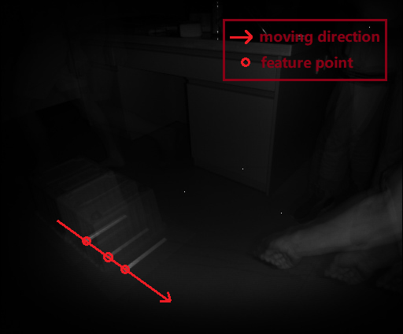

Figure 15. By tracking the endpoint of the reflective marker, we can track the moving direction of the conveyor belt.

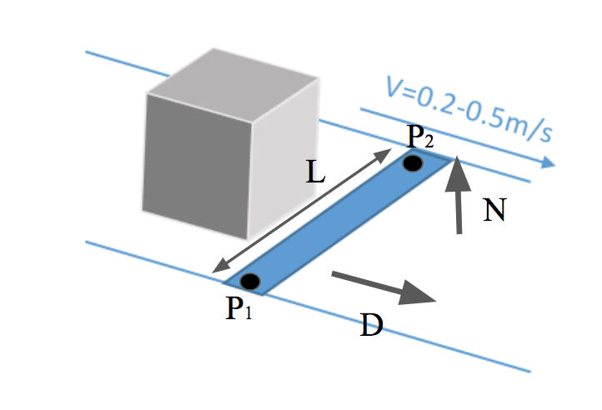

Figure 16. Schematics for calculation of the endpoint of the reflective strip

**Shape Construction**: We construct the shape of the cargo object from the point cloud using the random incremental algorithm, which is a popular algorithm to generate convex hull from point clouds. Detailed description of the algorithm is presented in Manufacturing Plan section. The shape generated using the algorithm from the pont cloud in Figure 14 is shown in Figure 17.

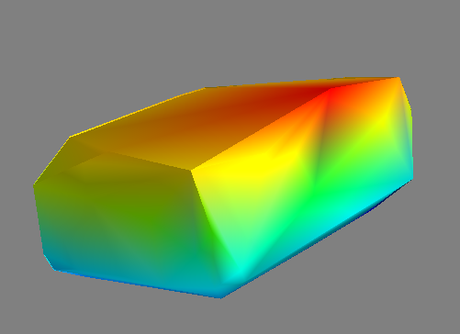

Figure 17. The shape generated from the point cloud in Figure 14 with random incremental algorithm

**Volume and Size Estimation:** The algorithm is conducted using the following steps, and is demonstrated in Figure 18.

1. Determine the vertical direction to the conveyor belt
2. Find the center of t weight of the object
3. Choose the Axis pass through the center of weight
4. Get the length d among the cross section
5. Rotate the cross section to get a couple of *d*s
6. The width vector is on the surface of cross section with minimum *d*
7. Get the length vector which is perpendicular to width

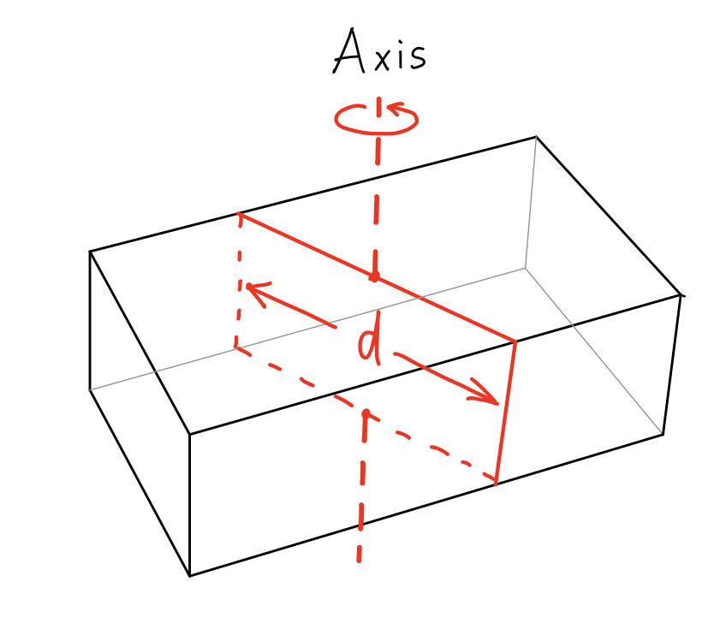

Figure 18. Schematic for volume and size estimation

# Parameter Analysis

Since the most important engineering specifications for the project are the accuracy for the shape detection, size of the object, and the distance from the Kinect camera to the conveyor belt is crucial for both engineering specifications. Following is the engineering analysis to determine the distance.

In our test with the Kinect camera, we discovered that as the distance from the Kinect camera to the object is increased, the error for depth measurement will also increase, as demonstrated in Figure 19. However, the field of view will also increase as the kinect camera moves away from the object. As demonstrated in Figure 20, the the field of view of the camera is calculated using Equation 3, where *FOV* represents field of view, *WD* represents the working distance, *h* is the size of the image, and *f* is the focal length of the camera. Thus, we need to choose the distance large enough that enable the Kinect camera to see the whole object, while keep the distance as small as possible to increase the detection accuracy. Based on the engineering specification that the largest size of the object has a side length of 50*cm*, the distance from the camera to the conveyor belt can be calculated using Equation 4, where *L* is the side length of the cargo object, and *SF* represents the safety factor on the size of the object. Considering a safety factor of 1.5, the distance from the Kinect camera to the conveyor belt is determined as 1.2*m*.

$FOV=WD×h/f$ (3)

$WD=SF×L×f/h+L$ (4)

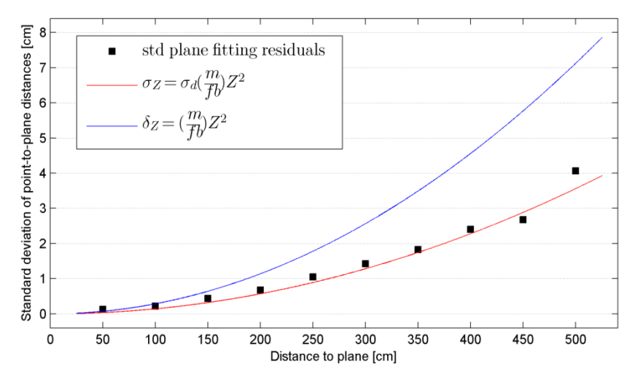

Figure 19. Detection accuracy vs distance for kinect camera

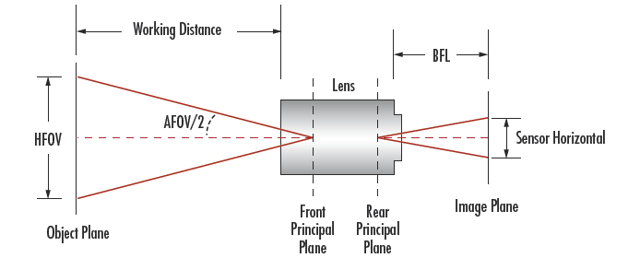

Figure 20. Demonstration of FOV calculations [17]

# Final Design

As shown in the functional flowchart in Figure 10, the system consists of mechanical part and software part.

For the mechanical part, we assume that the conveyor belts are already equipped by customers. So the design only consists 2 Kinect cameras, 2 mounting of the Kinect cameras and the placement of reflection strips. Detailed dimensions of the device setup is shown in Figure 12. The distance between the cameras along the conveyor belt direction is 1*m*, and both cameras are placed at the height of 1.2*m* above the conveyor belt. The view angles of the two cameras are set as 45° staggered configuration, and each camera has a 45° view angle facing downward. The reflection strips are 3*cm* in width and 50*cm* in length, and mounted in parallel on the conveyor belt with a gap of 2 meters.

Two computers connected under the same LAN provides the hardware support for running the algorithms. The software part consists of algorithms for point cloud generation, background elimination and denoising, cargo detection, coordinate conversion and point cloud alignment, volume estimation, and 3D model output. Detailed explanation of the software part is presented in the concept description section.

In our prototype, we use the conveyor belt with smooth surface, which may reflect the environment light and disturb the accuracy of depth cameras. In real practice, the surface material will be more anti-reflective so the measurement accuracy will be improved.

However, we consider a static simple background in our prototype. However, in the real-world application, the background may be more complicated and consist of moving objects. Those factors may cause disturbance to our system, and reduce the performance of our system.

# Manufacturing Plan

There is no material in the project that requires manufacturing. The Kinect cameras can be mounted to the support structure through a screw-net connection, as shown in Figure 21. The view angles can be adjusted using the adjustment screws. The reflective strips can be directly stick onto the surface of the conveyor belt.

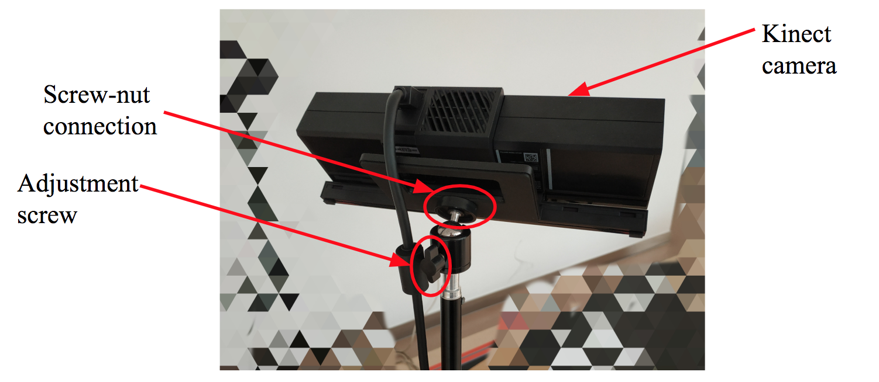

Figure 21. The Kinect camera can be directed mounted to the stand with the standard screw.

The program is written in Python 2.7 version under Ubuntu 16.04 environment, and the source codes and libraries are listed in Table 2.

The libraires *libfreenect2* and *pylibfreenect2* are used to interface between python and the kinect cameras. With these two libraries, we can read the depth and infrared image from the kinect cameras in real time. As described in Equation 1, the function to transfer the point cloud into 3D point cloud is also implemented in the libraries.

The *opencv3.3* library is used for the detection of the reflection strip, and denoising the point cloud. The *cornerHarris* function implements the Harris corner detector, which is used to detect the end point of the reflection strip from the infrared image. The corner detector can detect the change of intensity in all directions, and detect the corners in the image. The *morphologyEx* function implements the morphology transform, and is used to filter the noise of the point cloud.

The *numpy* library is used to manipulate the matrices and images in python. With the class type *ndarray*, we are able to store the images, point clouds and transform matrices. We also used the function *dot* to perform matrix multiplication to perform the spatial transformation of our point cloud, as in Equation 5, where T is the $3×4$ spatial transformation matrix, $(x_{},y,z,1)$ is the homogeneous coordinate of the original point, $(x_{new},y_{new},z_{new})$ is the 3D coordinate of the transformed point.

$(x_{new},y_{new},z_{new})=T∙(x_{},y,z,1)$ (5)

The *mayavi* library is used for visualization of the polyhedron and the point cloud. We used the library to construct the user interface of our system, and help with the debugging process.

The *icp* repository is used for refined point cloud alignment. It is a public available repository on github that implements the iterative closest point (ICP) algorithm. ICP algorithm is used to align two point clouds. In the algorithm, each point in the first point cloud is matched with its closest point in the second point cloud. Using the correspondence relation of all the point pairs, singular value decomposition (SVD) method is used to calculate the transform between the two point clouds that minimizes the least square error of point-to-point distances. By iteratively computing the correspondences and computing the transform, a refined alignment of the point clouds can be derived through the algorithm.

The random incremental algorithm is implemented by ourselves to construct the shape of the cargo object from the point cloud. In the algorithm, four random points from the point cloud are selected to form a tetrahedron. All the points inside the tetrahedron are disregarded. Then, we repetitively select and a random point $p_{r}$ outside the polyhedron, and delete the surfaces of the polyhedron that are visible from the point, as shown in Figure 22. New surfaces are constructed with the new point and the “horizon”, which is composed of visible edges from $p_{r}$. The process is repeated until all the points are inside the polyhedron, and the polyhedron is the shape of the object.

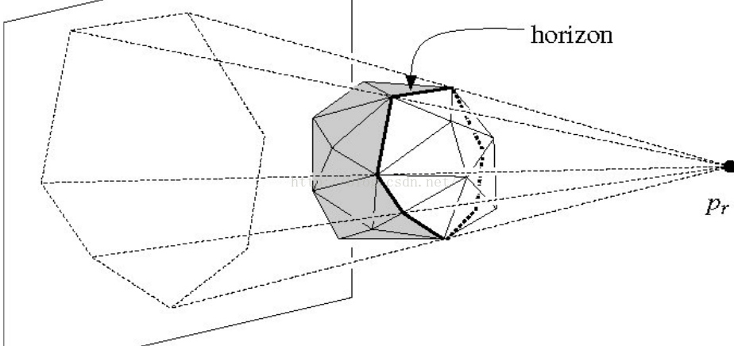

Figure 22. Demonstration of random incremental algorithm. The white surfaces represent the visible surfaces from $p_{r}$, which are deleted. The horizon is marked with thick lines. [18]

The cost of the system and our budget are shown in the bill of materials in Appendix A. Since the Kinect cameras and the computers are provided by our sponsor, our total cost is￥3310, which lies within our budeget.

|  |  |  |  |
| --- | --- | --- | --- |
| **Name** | **Type** | **Function** | **Link** |
| Ubuntu 16.04 | Environment | Environment to run the programs and functions | https://www.ubuntu.com/download/desktop |
| libfreenect2 | Library | Driver for Kinect for Windows v2 (K4W2) devices (release and developer preview). | https://github.com/OpenKinect/libfreenect2 |
| pylibfreenect2 | Library | A python interface for libfreenect2 | https://github.com/r9y9/pylibfreenect2 |
| Opencv 3.3 | Library | We use Opencv to denoise the image and fit the moving direction of the cargo | https://opencv.org/ |
| numpy 1.15.0 | Library | A python library to manipulate matrices and images | http://www.numpy.org/ |
| Mayavi | Library | A Python library to visualize the polyhedron and point cloud | http://docs.enthought.com/mayavi/mayavi/ |
| TraitsUI | Library | A Python library to support customer-defined GUI | http://docs.enthought.com/traitsui/ |
| icp | Source code | A python repository on github that implements the ICP algorithm | https://github.com/ClayFlannigan/icp |

Table 2. Environment, source codes, libraries used in the system.

# Test Results

We design a set of experiments to validate the functions of the cargo volume estimation system. The engineering specification to be validated in the experiment include maximum and minimum of cargo size, unilateral error, conveyor belt speed, and process time.

The experiment setup is shown in Figure 23. In the experiments, we place object of different shapes and sizes on a conveyor belt with 0.6m width and 3m length. With the conveyor belt moving at different speeds, we record the estimated sizes of the objects, and compare it to the ground truth sizes by physical measurements to calculate the unilateral errors. The execution time is also recorded for each trial, and compared with the engineering specification. We expect all the engineering specifications to be met because our previous experiences indicate the accuracy and efficiency of the system.

We used three boxes with different sizes for our test: 38*cm* * 25*cm* * 21*cm*, 30*cm* * 12.2*cm* * 15*cm*, 28.5*cm* * 29*cm* * 22.4*cm*. We conducted 20 tests for each object with the conveyor belt moving at 0.3*m/s* and 0.4*m/s* respectively. We placed the object at different locations and orientations on the conveyor belt, and record the results of unilateral error and deviations in Table 3. The execution time in the tests is recorded in Table 4. From the experimental results, our system is able to estimate sizes of cargos ranging from 10*10*10 $cm^{3}$ to 40*40*40 $cm^{3}$ in real time with a unilateral error within 10%.

Other engineering specifications including camera distances, camera angles can be validated through physical measurement. The cost can be validated through our bill of materials.

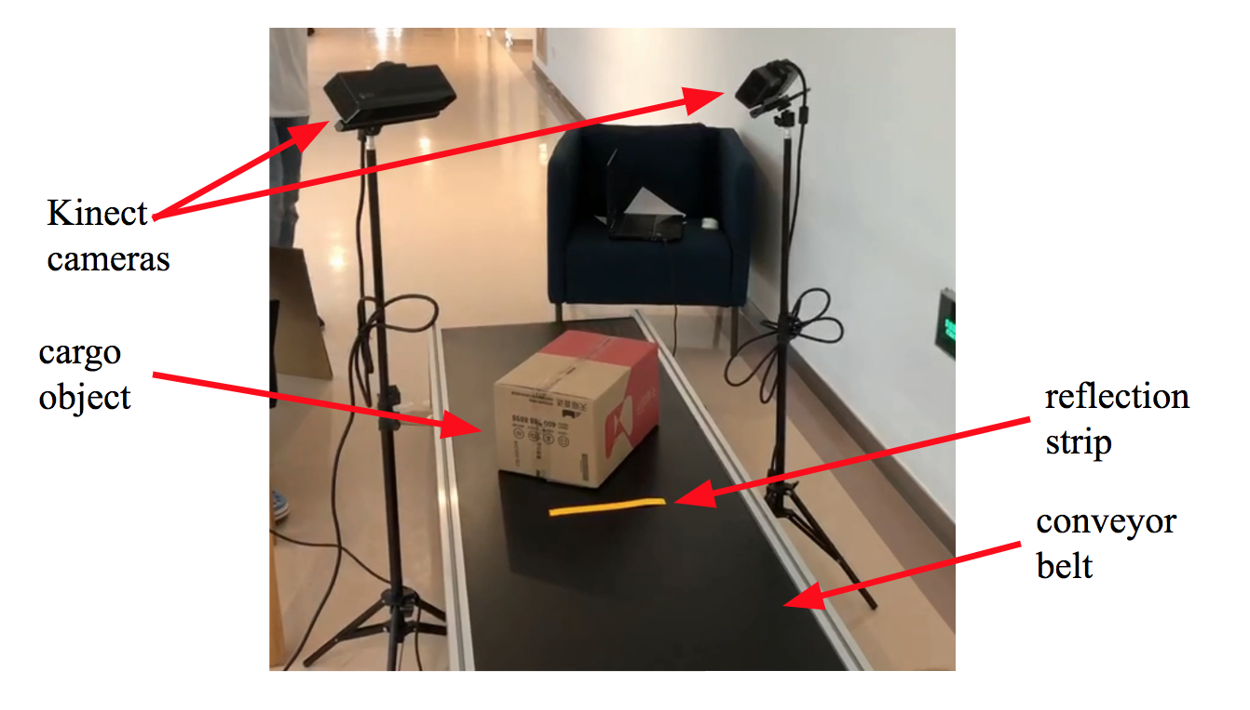

Figure 23. Validation experiment setup

|  |  |  |  |
| --- | --- | --- | --- |
| Cargo | Speed | 0.3*m/s* | 0.4*m/s* |
| Test Cargo 1  (38*cm* * 25*cm* * 21*cm*) | Length Error | 2.6±0.7% | 8.2±1.5% |
| Width Error | 9.3±1.9% | 8.5±2.3% |
| Height Error | 2.1±1.3% | 1.5±2.1% |
| Test Cargo 2  (30*cm* * 12.2*cm* * 15*cm*) | Length Error | 2.4±1.9% | 5.6±2.5% |
| Width Error | 8.4±1.7% | 9.2±1.1% |
| Height Error | 1.7±0.7% | 1.3±2.1% |
| Test Cargo 3  (28.5*cm* * 29*cm* * 22.4*cm*) | Length Error | 7.5±2.4% | 8.0±3.3% |
| Width Error | 4.8±2.1% | 4.2±2.9% |
| Height Error | 1.3±1.5% | 2.0±2.1% |

Table 3. Unilateral error and size variation in tests

|  |  |  |
| --- | --- | --- |
| Cargo | Execution Time (*s*) | Maximum Execution Time (*s*) |
| Test Cargo 1  (38*cm* * 25*cm* * 21*cm*) | 0.54 | 0.98 |
| Test Cargo 2  (30*cm* * 12.2*cm* * 15*cm*) | 0.52 | 0.83 |
| Test Cargo 3  (28.5*cm* * 29*cm* * 22.4*cm*) | 0.60 | 1.12 |

Table 4. Execution time in tests

# Engineering Changes Notice (ECN)

In the final prototype, we improved our algorithms. After capturing the point cloud, we project the point cloud to a axis, then we remove the outliers according to the sorted result. The axis rotates in different direction, which makes sure any potential outlier removed. For the convex hull, previously we used a random sample as the basis of convex hull, which may be unstable. In our final design, we firstly project the points to xy-plane, then a 2D convex hull algorithm is applied. We use the points on 2D convex hull as the basis of 3D convex hull.

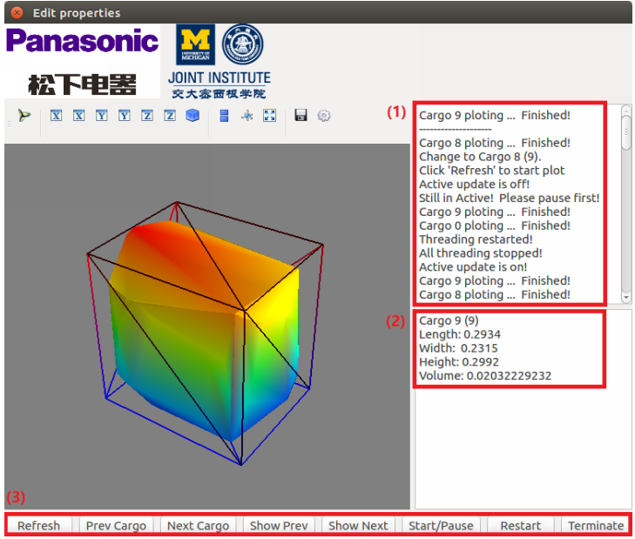

Figure 24. GUI demo

We also add a GUI to make the interface more user-friendly, as shown in Figure 24. Our GUI mainly includes 4 parts: 3D output, logging (1), cargo statistics (2), and functional buttons (3). The 3D output shows the 3D model of the cargo and the smallest cuboid which can enclose the cargo. The logging (1) displays all the operation history. The cargo statistics (2) displays the calculated size of the cargo, includes the length, width, height and volume. And functional buttons (3) includes all the functional operations such as checking the statistics of previous cargo.

# Analysis of Potential Problems

There still remains some oversights in our system design, which mainly include the aliasing problem and the misalignment problem. Following paragraphs demonstrate potential problems, and our plan for solving the problems.

Since there are several reflection tapes on the conveyor belt, the algorithm may encounter the problem of aliasing in reflection tape detection, which means the algorithm will regard two different reflection tapes as the same one. This problem will cause severe errors in point cloud alignment. To solve the problem, we plan to add speed and timing information into our algorithm. Knowing the time interval and speed of the conveyor belt, the algorithm can distinguish different reflection tapes, and avoid the aliasing problem.

Another problem is the misalignment of point clouds. In the case when there are some unpredicted errors in the calculation of the point cloud transform, the two point clouds may not align well with each other, and the constructed shape will be distorted. To solve the problem, we plan to estimate the goodness of the fit by computing the point-to-point distances, and disregard the frames with large errors. In this case, the robustness of the system will be increased.

# Discussion

Our design has the following strengths:

Our system is easy to install and use. The positions and filming angles of cameras are fixed regardless of the size of the cargo and the speed of the conveyor belt. The parameter calibration is needed only during installation. So our system only needs to be set up for one time, and doesn’t need to adjust frequently.

Our system is automatic, so little human labor is required to run the system. And it has capability of measuring cargos of a wide range of sizes. We made use of both the depth and IR images taken by Kinect cameras. Compared to just using depth images, reflection tapes are much easier to be detected in IR images. IR images make it easier to find reference points and detect the cargo.

Our design costs less money than the competitors existing in the market. The common way of measuring the volume of cargo is to measure the distance of its surface to infrared ray launcher. The cost of an infrared ray grating might will cost more than 10,000 RMB, which makes it not capable of mass equipment. Our design, however, cut the cost down to 3,200 RMB. So it is very affordable for small companies to equip, and mass equipment for larger companies.

Our design still has some weaknesses:

Our design cannot align point clouds very accurately, there still exists slight misalignment. This is the main reason for errors. The reason for this inaccuracy is the aligning algorithm. Currently the biggest problem with our aligning algorithm is that there exists some horizontal rotational error. The small angle difference between two point clouds causes the length and width of our estimation to be larger than theory. We tried ICP algorithm to tune the small angle, but the outcome is not satisfactory. So we need to find more sophisticated algorithms to calculate the best transformation between two point clouds, or we can apply an adjustment constant to the result according to some experimental values.

We have currently only tested for single object detection. The system cannot handle consecutive objects measurement, which requires us to make the distance between cargos very large (about 1.5m). If we have time, we should better improve our algorithm to reduce the distance between cargos to about 1m.

# Recommendations

We pretty enjoyed our cooperation with our sponsor, Panasonic. Our sponsor gave us detailed engineering specification for reference and many other aids on the project. We highly recommend the initial engineering specifications given by Panasonic. Due to limited time, we have to modify some of the specifications, and our sponsor approved of that. But the initial values are still very useful. If there are groups that will continue with our project, we will encourage them to make some progress on our current project and try to satisfy all the initial specifications.

Here we have some suggestions to make the project better. The first one is to search for more sophisticated algorithm for point clouds alignment. The key performance of our project is the accuracy of estimating cargo volume. Although we can fulfill the requirement of 10% unilateral error, we think the error can be further reduced. Secondly, we recommend further groups to find ways to detect multiple objects in one graph. Currently we can only detect single object in one graph, which means the distance between two cargos is very long(1.5m), but it is better to reduce the distance to about 1m. This improvement can improve the efficiency of this project. One effective way is to search for algorithms that splits two distant clusters of point clouds, because under depth image, two objects are represented by two clusters of point clouds. We can tell one object from other by classifying the point clouds according to their distances to the camera ad the distance between each other. Thirdly, we will recommend further groups, or our sponsor to provide a better conveyor belt. The current conveyor belt we have can reflect natural light due to its material, this introduces large noise to the depth image. Those areas that reflects the light will be regarded as infinitely far from the camera, which is very terrible. To deal with this problem, we have to lay two paper boards on the conveyor belt to let the system initialize the parameters.

Thus it is better to have a conveyor belt using materials with lower reflection rate. Finally, we hope further groups can measure the cargos of wider sizes. We cannot measure cargos as small as 5*5*5 $cm^{3}$ or as large as 50*50*100 $cm^{3}$, which is initially required by our sponsor, because of the accuracy of the camera. We believe this project will be more competitive if our successors can overcome this problem.

# 

# Conclusions

To conclude, our project is to fulfill the requirements of our client, Panasonic, to build an automatic system to measure the volume of cargoes on a conveyor belt. The system is required to have high efficiency and accuracy, standardized measurement process, easy accessibility to build, install and use, high compatibility to measure cargo of different sizes and various shapes, and preferably visualized output. Among those, the most important two are compatibility and accessibility.

We translated the requirements into engineering specifications. As a result, the main hardware we are going to use are two kinect 2.0 depth cameras, and mechanical structures to support the cameras. In comparison with existing products in the market, our system requires fewer hardware supports, and thus cuts down the cost. The system estimates the shape and size of cargo objects ranging from 10*10*10 $cm^{3}$ to 40*40*40 $cm^{3}$ in real time. Meanwhile, we restrict the unilateral error of our volume measurement to be under 10%, an acceptable value for our customer, to assure the accuracy. Therefore, we are confident to exhibit a solid design and further build a promising product.

# Acknowledgements

We would like to give our special thanks to Panasonic for sponsoring our project. Moreover, we would like to acknowledge the help from our mentor Mr. Zhuosi Zhang from Panasonic, and our instructor Dr. Mingjian Li from UM-SJTU Joint Institute. Finally, we are grateful to Prof. Chengbin Ma and all other course staff of VE450.

# 

# Information Sources and Reference List

[1] Newcombe, Richard A., et al. "KinectFusion: Real-time dense surface mapping and tracking." *Mixed and augmented reality (ISMAR)*, 2011 10th IEEE international symposium on. IEEE, 2011.

[2] J. Loera, J. Rambau and F. Santos (2010), *Triangulations: Structures and Algorithms* (2nd revised ed.), Springer-Verlag, ISBN 9783642129711 Chapter 3: Polygon Triangulation: pp.103.

[3] Besl, Paul J.; N.D. McKay (1992). "A Method for Registration of 3-D Shapes". *IEEE Trans. on Pattern Analysis and Machine Intelligence*. Los Alamitos, CA, USA: IEEE Computer Society. 14 (2): 239–256. doi:10.1109/34.121791

[4] Pirovano, Michele. "Kinfu–an open source implementation of Kinect Fusion+ case study: implementing a 3D scanner with PCL." no. October 2012 (2011).

[5] Kakinoki, Yoshikazu, Masato Nakashima, Tetsuo Koezuka, Noriyuki Hiraoka, Hiroyuki Tsukahara, Yoshinori Suto, Yoshitaka Oshima, and Shinji Hashinami. Optical System for Detecting Three-dimensional Shape. Fujitsu Ltd, assignee. Patent US5004929A. 2 Apr. 1991. Print.

[6] Itsuzaki, YasuoYoshihiro, Masatoshi Nakamura, Noriyuki Suzuki, Misuzu Takano, and Kinji Horikami. Shape Detection Apparatus. Panasonic Corp, assignee. Patent US5995663A. 30 Nov. 1999. Print.

[7] Nakagawa, Yasuo, and Shree Nayer. Method of Detecting Solid Shape of Object with Autofocusing and Image Detection at Each Focus Level. Hitachi Ltd, assignee. Patent US5151609A. 29 Sept. 1992. Print.

[8]. Specification for “Heavy Duty Slider Bed Conveyor - Model TL 42" OAW, 17'-1" long”,

Hytrol Conveyor Company, Inc. http://www.cisco-eagle.com/catalog/product/12410/

heavy-duty- slider-bed-conveyor-model-tl-42-oaw-17-1-long

[9]. “Kinect for Windows Sensor Components and Specifications” https://msdn.microsoft.com/en-us/library/jj131033.aspx

[10]. K. Khoshelham, S.O. Elberink, “Accuracy and resolution of Kinect depth data for indoor mapping applications”, Sensors, 12:1437–1454, 2012.

[11]. Li, Lingling, Z. Wang, L. Qing, and H. He, “Fast Volume measurement based on Kinect 2.0 depth image”, *Microcomputer & Its Applications,* vol. 1, no. 7, 2017, pp. 35-38.

[12]. Dellen, Babette, I. Rojas, “Volume measurement with a consumer depth camera based on

structured infrared light”, 16th Catalan Conference on Artificial Intelligence, poster session, 2013, Vic, Spain, pp. 1-10, ACIA.

[13]. https://arxiv.org/abs/1612.01925

[14]. Dung, Lan Rong, C.M. Huang , Y.Y Wu, “Implementation of RANSAC Algorithm for Feature-Based Image Registration”, *Journal of Computer and Communications*, 2013, 1, 46-50

[15]. Segal, Aleksandr, Dirk Haehnel, and Sebastian Thrun. "Generalized-icp." In *Robotics: science and systems*, vol. 2, no. 4, p. 435. 2009.

[16]. Ringnér, Markus. "What is principal component analysis?." *Nature biotechnology* 26, no. 3 (2008): 303.

[17]. https://www.edmundoptics.com/resources/application-notes/imaging/understanding-focal-

length-and-field-of-view/

[18]. https://blog.csdn.net/theArcticOcean/article/details/50646428

# Appendices

## Appendix A. Bill of Materials

|  |  |  |  |  |
| --- | --- | --- | --- | --- |
| **Quantity** | **Part Description** | **Purchased From** | **Part Number** | **Price (￥/each)** |
| 2 | Kinect cameras | Provided by sponsor | 74Z-00001 | 1488 |
| 4 meters | Reflective strip | Taobao* |  | 10 per meter |
| 2 | Camera support | Taobao* |  | 35 |
| 1 | Conveyor belt | Taobao* |  | 3200 |
| 1 | Computer with Ubuntu environment | Provided by sponsor |  | N.A. |
| *https://world.taobao.com | | | **Total Cost** | **3310** |

Table 5. Bill of Material for the system

## Appendix B. Illustration of solutions and concept selection process

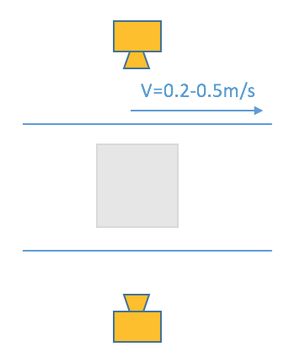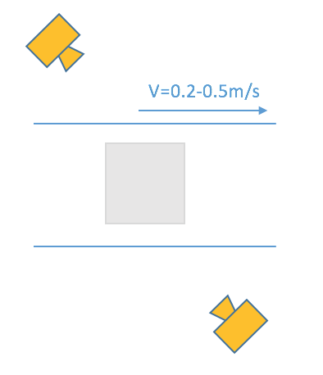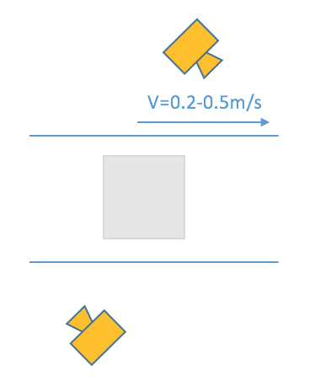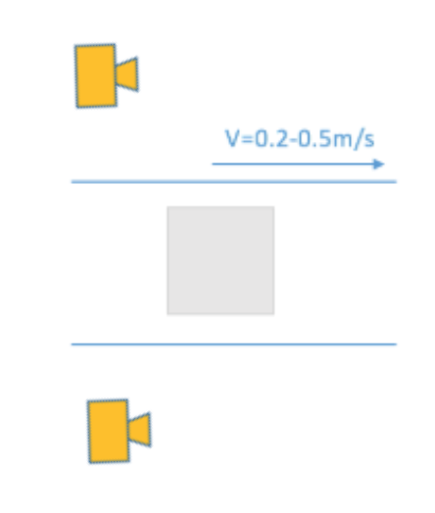

Figure 25. Demonstration of camera placement configurations. From left to right: 90°, 45°, 45° staggered, 0°

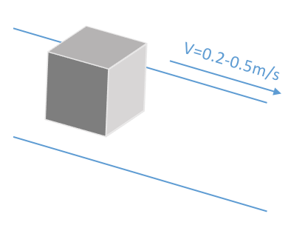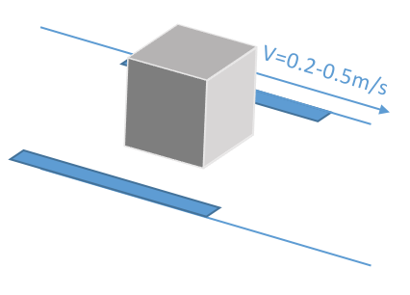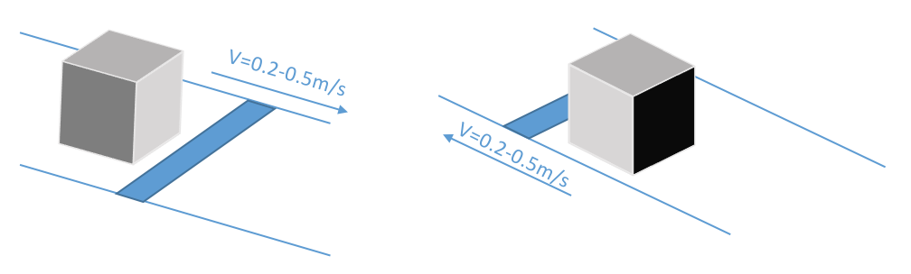

Figure 26. Demonstration of reflective strip placement configurations. From left to right: no reflective tape, side configuration, front configuration.

## 

## Appendix C. Project Timeline and Schedule

Figure 27 shows the schedule for our project in Gantt Chart. There are four milestones marked in red: Design Review 1, Design Review 2, Design Review 3, and EXPO. We have arranged our schedule into 5 parts: the first part is background research, and the other four parts correspond to the four milestones.

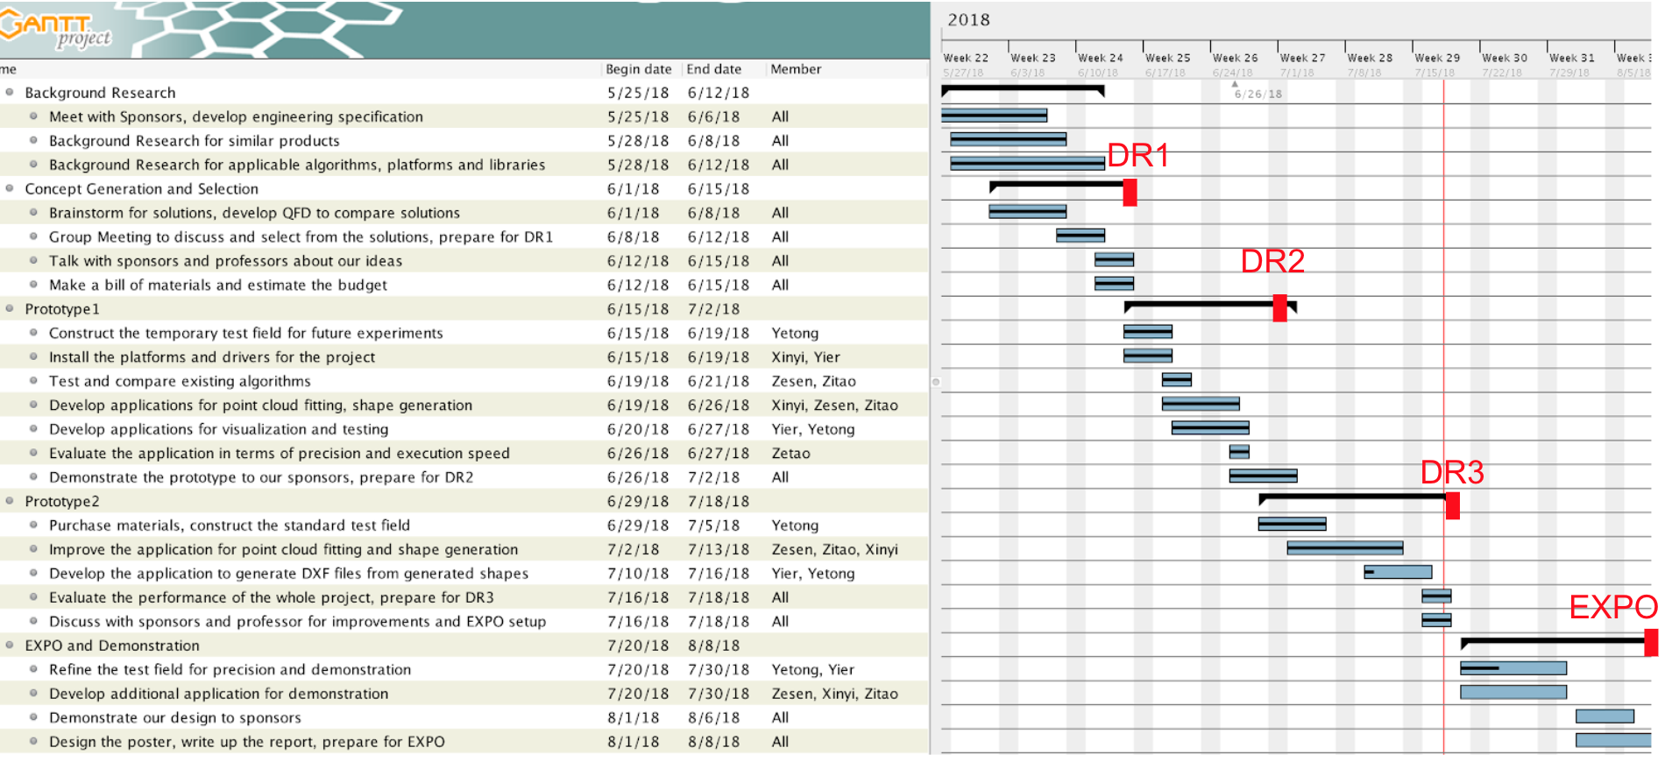

Figure 27. Project Schedule.

# Bios

Zesen Wang:

I’m an undergraduate student at University of Michigan - Shanghai Jiao Tong University Joint Institute majoring in electrical and computer engineering. Also, I joined the 3+2 program with Royal Institute of Technology majoring in machine learning, so I’m also a graduate student at KTH.   
In the next year, I’m going to finish my courses at KTH and to work on the master thesis. I joined some industrial field trips to companies like Spotify, and I learned about some application of knowledge in machine learning in practical projects in companies. Visiting real workplace and listening to stuff there really inspire me of how to develop my skill set in the future. In the next two years, except for the courses given by the university, I plan to learn some practical skills that help me to work on large projects like techniques on mass data storage and distributed computation setup which does not come up in the courses I learn because in the university courses, students always work on simplified demos instead of real products. I hope the capstone design and the master thesis in next year can give me more experience on working on real products.

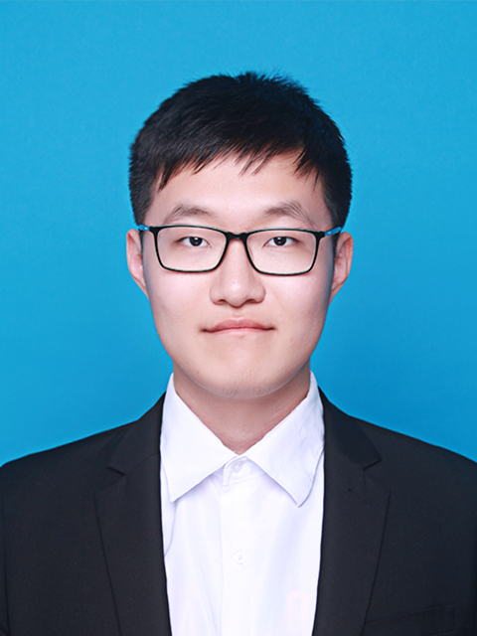

Zitao Zhang

I'm Zitao Zhang, a senior ECE student. I'm interested in computer science, so I would like to work in a relative field in the future. I've worked as an internship in eBay Shanghai last year, which gives me a lot of working experience, such as how to cooperate with other group members in a same developing project. And it also let me realize that I still need further learning to expand my skills and knowledge. So I attended the 3+2 program, studied at KTH Royal Institute of Technology as a master student in the passing semester. My major is Machine Learning, which is a very popular field recent year. It is a quite cool subject. I've learned a lot about AI and deep leaning. This technology can be used in a wide range, such as image classification, voice recognition, and model designing.

I haven't decided yet about whether I would go to work or apply for a Ph.D. after finishing my master degree. The machine learning is a very hot field, so it might not be too difficult for seeking a job in this field. But if I want to work in a good position in a good company in future, only a master degree seems not enough. Another problem is that it could be very difficult for applying a Ph.D. in machine learning or AI because of the intensive competition. Maybe I need to collect more information during the second-year study in KTH, to decide which way would be more suitable for me.

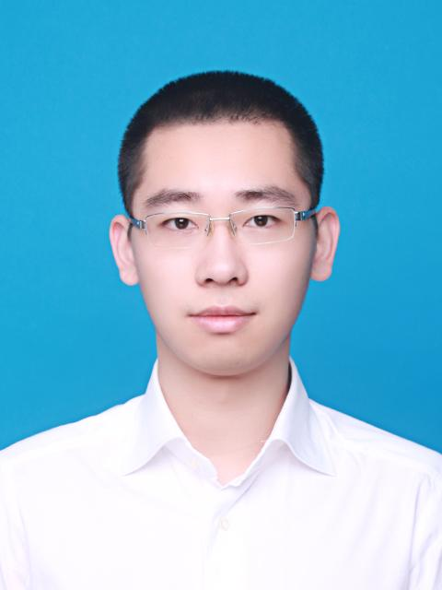

Yier Zhang:

I’m Yier Zhang, senior student at the University of Michigan, Shanghai Jiao Tong University Joint Institute. My major at JI is Electrical and Computer Engineering, and major at UM is Electrical Engineering. Courses I’ve taken include VLSI design, computer architecture, embedded systems and control systems design. I’m interested in embedded systems and design, and I enjoy building something fancy. During my embedded systems design course, my teammate and I built a drawing robot that mimics human’s writing on a resistive touch screen. I also have some experience in machine learning, I collaborated with another student to write a few learning programs such as the “Pong” game, where a pad is controlled to rebound a ball and break as many bricks as possible. I think the “AI rush” will keep for a long time, so as a new comer I need to gain more experience in this field. I have an internship experience in company, and I quite enjoyed the atmosphere working in a small team. After this semester, I will go to America for graduate study in ECE. I hope after my graduation, I can join the industry and develop a product of my own.

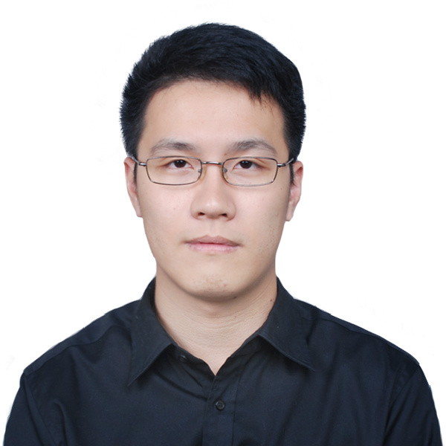

Yetong Zhang:

I’m Yetong Zhang, a senior student from UM - SJTU Joint Institute. I have received the bachelor's degree in computer engineering at University of Michigan, and I’m now pursuing degree in mechanical engineering at Shanghai Jiao Tong University. I am interested in robotics, and I will go to Georgia Tech for PhD with a focus on the intersection field of robotics and reinforcement learning. From my interdisciplinary education background, I have gained rich experience in mechanical design, system control, computer vision and artificial intelligence. During my internship at DJI, I joined a research team in developing computer vision detection algorithms using deep learning methods. This is also my first project to learn about the product design process, and understand the robotics industry. I have also got research experience from Structural Dynamics Lab, Autonomous Robotic Manipulation Lab, and Vision and Learning Lab during my study at University of Michigan. In the future, I hope to increase the intelligence of robotics with smarter algorithms, so that they can better facilitate people’s daily life. In addition, I am also a tourism enthusiast, an old driver, a good table tennis player, and a handsome single man.

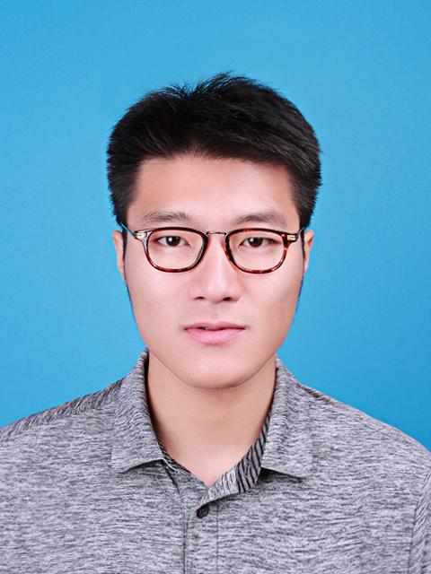

Xinyi Wu:

I am Xinyi Wu, majoring in Electrical and Computer Engineering at the joint institute and Data Science at the University of Michigan. My research interest is natural language processing, specifically, to understand expressions and underlying information using data mining and machine learning techniques combined with linguistics insight. The ultimate goal is to break the boundaries of communication across knowledge and cultures.

In order to sharpen my skills in this field, I actively participated in research and internship. Under the instruction of Professor Rada Mihalcea, director of UM AI Lab, I developed a system to automatically understand and evaluate the motivational interviewing. Besides, I analyzed disparities of Twitter interaction of people in different relationships in order to build online social network. Moreover, I built a multi-product pricing system at JD.com, and improved a map-matching algorithm at UM Transportation Research Institute. Later, I will attend the University of Washington for a master’s degree to further enhance my knowledge and research abilities.

